|  |
| --- |
| NORTH TEXAS HIGH SCHOOL RODEO ASSOCIATION RULE CHANGE REQUEST FORM |

|  |
| --- |
|  |

**Directions for completing, printing, and turning in this form:**

1. Enter the appropriate information in to the boxes to the right of “CHAPTER”; “ARTICLE”; “SECTION”; “PAGE”
2. Copy and paste, or type the CURRENT RULE AS WRITTEN next to the arrow under letter A)
   1. If new rule type “N/A” next to that arrow
3. Type the version of the rule that you would like written and seen in the rulebook next year next to the arrow under letter B)
4. Print the form
5. Sign your name in the space provided
6. Print your name and phone number in the space provided
7. Keep a copy for yourself
8. Drop the signed Rule Change Request form in to the NTHSRA mailbox before 5:30pm Sunday, April 16, 2023
9. A completed example is below:

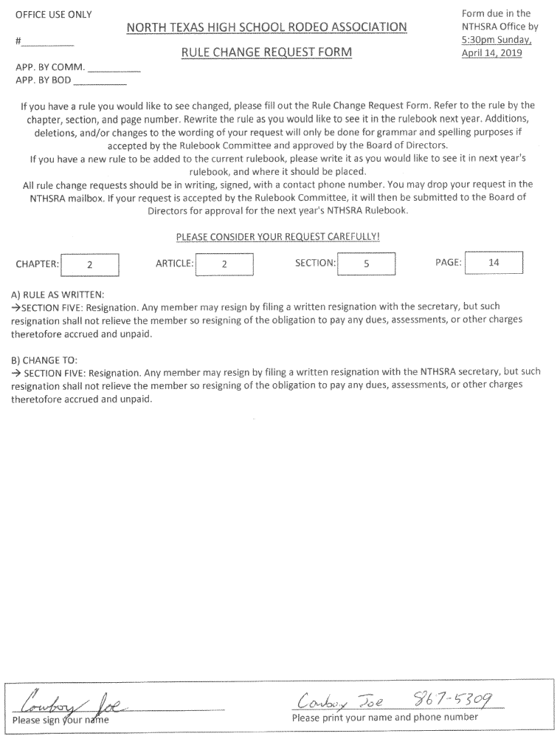

OFFICE USE ONLY Form due in the

NORTH TEXAS HIGH SCHOOL RODEO ASSOCIATION

RULE CHANGE REQUEST FORM

NTHSRA Office by

#__________ 5:30 pm Sunday,

April 13, 2025

APP. BY COMM. __________

APP. BY BOD __________

If you have a rule you would like to see changed, please fill out the Rule Change Request Form. Refer to the rule by the chapter, section, and page number. Rewrite the rule as you would like to see it in the rulebook next year. Additions, deletions, and/or changes to the wording of your request will only be done for grammar and spelling purposes if accepted by the Rulebook Committee and approved by the Board of Directors.

If you have a new rule to be added to the current rulebook, please write it as you would like to see it in next year's rulebook, and where it should be placed.

All rule change requests should be in writing, signed, with a contact phone number. You may drop your request in the NTHSRA mailbox. If your request is accepted by the Rulebook Committee, it will then be submitted to the Board of Directors for approval for the next year's NTHSRA Rulebook.

PLEASE CONSIDER YOUR REQUEST CAREFULLY!

CHAPTER: ARTICLE: SECTION: PAGE:

A) RULE AS WRITTEN:

🡪

B) CHANGE TO:

🡪

________________________________________ ________________________________________

Please sign your name Please print your name and phone number