NORTH TEXAS HIGHSCHOOL RODEO ASSOCIATION
QUEEN CONTESTANT ENTRY FORM NAME_________________________________________________________NTHSRA NO.__________ 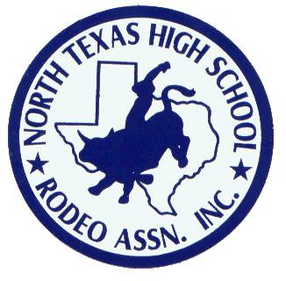
ADDRESS_____________________________________________________CITY__________________
ZIP_______________________HOME/CELL PHONE________________________________________
RODEO TEAM SPONSOR______________________________________________________________
YOUR PRESENT RODEO TITLE (IF ANY)________________________________________________
SCHOOL YOU ATTEND_________________________________________________GRADE_______
RODEO EVENTS IN WHICH YOU PARTICIPATE_________________________________________

If I am crowned Miss NTHSRA., I promise to represent NTHSRA and promote the sport of rodeo to the best of my ability during my rein. I will be introduced in full queen attire (sash, crown, and buckle) in at least one performance of at least 75% of all NTHSRA approved rodeos and compete in 50% or more NTHSRA approved rodeos. I will attend all general membership meetings dressed in full queen attire (sash, crown, and buckle) and be dressed the same anytime I am representing NTHSRA. As a good will ambassador for NTHSRA, I will represent myself as a lady at all times and will not put myself in any situations of alcohol, drugs, abusive language, or immoral behavior. I also understand if I fail to fulfill my duties as Queen, I will relinquish my title to the first runner-up of the contest.
**I also understand I am required to collect a minimum of $100.00 in donation for Mr. North Texas and work no less than 5 hours at the Windy Ryon Memorial Rodeo. Failure to comply with these requirements will result in my disqualification from the contest.
____________________________________________________
Contestant’s Signature
The undersigned agree to comply with all rules and regulations of the NTHSRA Queen Contest, warrants no false representation has been made and hereby releases NTHSRA, their agents, Board of Directors, and employee from any and all claims for damages or injuries while participating in any activities of the Miss NTHSRA Pageant.
_____________________________________________________________ Date________________________________
Parent/Legal Guardian
_____________________________________________________________ Date________________________________
Contestant Signature
_____________________________________________________________ Date________________________________
Witnessed by
** $50.00 ENTRY FEE AND SPONSOR VERIFICATION MUST ACCOMPANY THIS ENTRY FORM.**
ENTRY DEADLINE: FRIDAY MARCH 10th BY 5:00PM

